­­­­­­

­­online seat BOOKING SYSTEM

1.INTRODUCTION

This document explains in detail about a project to test various programming skills of an individual. This will also enable us to access level of understanding an individual has about Web application technologies using Java based technologies. It also provides detailed instructions that should be followed while executing this assignment.

2.SCOPE

**2.1 Problem Statement:**

Every organization provides a space (seat) for the users to use. To make a seat reservation, the user will need to record their booking in a logbook. This logistics requires a lot of manual work to maintain the records, which tends to be an error prone approach. Hence, some automated approach is preferred, and the organization would like to have a seat booking system to improve the situation.

Using the seat booking system, user can first check the availability of their preferred seat and make the corresponding bookings online. The admin can check the booking status of the seat and have appropriate arrangements for the bookings. In addition, users can also view their booking histories via the interface. With this seat booking system user can instantly schedule desks, manage bookings, and locate neighborhoods and colleagues.

**Limitations with the current system:**

1. Not convenient to register a booking because the validation checking cannot scan all the invalid inputs by once time.

2. No calendar can be viewed in the system.

3. No timeline to show booking schedule.

4. No recurring booking can be performed.

5. No statistical report on seat usage.

**Benefits of seat booking system:**

1. Create a dynamic workforce

2. Maximize desk usage

3. Reduce costs

4. Understand your space

**2.1 Key Features:**

1. Application should allow the administrator to add, modify location, offices, floors and seats and able to remove offices, floor and seats, if needed.

2. Admin should be able to view number of available seats and booked seats.

3. Administrator should be able to deny any request.

4. User should be able to see remaining seat and be able to select available seat and book.

5. User should be able to update his/her personal information.

6. User should be able to view previous and future booking within a particular time.

7. User should be able to send seat cancellation request to admin.

3. ACRONYMS & ABBREVIATIONS

SRS - Software Requirements Specification

JPA -Jakarta Persistence API

4.FUNCTIONAL REQUIREMENTS

Below mentioned basic requirements to be implemented as part of SEAT Booking System:

**ADMIN:**

Should be able to approve and deny the seat booking request.

**USER:**

Should be able to see the available seats and can book the available seats. Once user has booked one seat no one else should be able to book, it should be disabled.

**4.1 Persona's/Actors**

Types of users:

|  |  |
| --- | --- |
| Persona/Actors | Description |
| User | Registered User who can login and make seat/cubicle booking. |
| Administrator | Admin User who can manage the administration module to be able to add office location, floor, seating capacity and approve /reject seat bookings. |

**4.2 Epics**

Epics of IFL System

|  |  |
| --- | --- |
| Epic Id | Epic |
| EP-1 | User Management Module |
| EP-2 | Administration Module |
| EP-3 | Cubicle Seat booking |

**4.3 User Story:**

User Story ID: EP1-OSB1

**User Story Title: User Registration**

As a User, I can register at the Online Seat Booking system, so that I am able login into Online Seat Booking system.

Business Rules

> User should be able to register themselves with a valid email id and password.

> Validate empty fields and validation patters like email id etc.,

User Story ID: EP1-OSB2

**User Story Title: User Login**

As a User, I can Login to Online Seat Booking system, so that I am able login and search for vacant seats to be booked.

Business Rules

> Registered users should be able to login to the Online Seat Booking system.

> Forgot password option to allow users to reset their password.

> Validation for empty fields and wrong credentials.

User Story ID: EP1-OSB3

**User Story Title: User Profile management**

As a User, I can Login to Online Seat Booking system, so that I am able manage my profile and bookings.

Business Rules

> Registered users should be able to update the profile details.

> Valid users should be able to reset their password.

User Story ID: EP2-OSB1

**User Story Title: Admin Login**

As an Admin, I can Login to Online Seat Booking system, so that I am able manage the Online Seat Booking system.

Business Rules

> Admin should have access to the administration section of Online seat booking system to update location / manage bookings etc.,

User Story ID: EP2-OSB2

**User Story Title: Office details Administration**

As an Admin, I can Login to Online Seat Booking system, so that I am able Update Office details.

Business Rules

> Admin should be able to:

Create / update office locations.

Floor details and layouts.

Seating capacity.

Manage available spaces.

User Story ID: EP2-OSB3

**User Story Title: Bookings Dashboard**

As an Admin, I can Login to Online Seat Booking system, so that I am able Manage Bookings

Business Rules

> Admin should be able to:

> View all bookings.

> View open capacity location wise, office wise and floor wise.

User Story ID: EP2-OSB4

**User Story Title: Bookings Approval**

As an Admin, I can Login to Online Seat Booking system, so that I am able approve seat booking requests.

Business Rules

> Admin should be able to approve / reject seat booking request.

> Every approval / rejection should notify the user who has booked.

> Admin should be able to disallow booking/ change seat allocation anytime and notify the respective user.

> Admin should be able to approve Cancellation of booking requests.

User Story ID: EP3-OSB1

**User Story Title: Seat Search**

As a User, I can Login to Online Seat Booking system, so that I am able search for open seats.

Business Rules

> Logged in user should be able to search for open vacant seats for a given Location, Office and floor, all open seats should be shown in green.

User Story ID: EP3-OSB2

**User Story Title: Seat Booking**

As a User, I can Login to Online Seat Booking system, so that I am able search for open seats to book.

Business Rules

> All open vacation seats should be shown in green.

> User should be able to book a seat for a particular duration.

> Once booked that seat should be shown in grey and disabled.

6.TECHNICAL DETAILS:

1.Eclipse IDE (JAVA EE)

2.Maven Build Tool

3.Spring Boot

4.DBMS: PostgreSQL

5.Spring initializr

6. Junit-Mockito

5.1 Use Case Diagram:

Use Case Diagram:

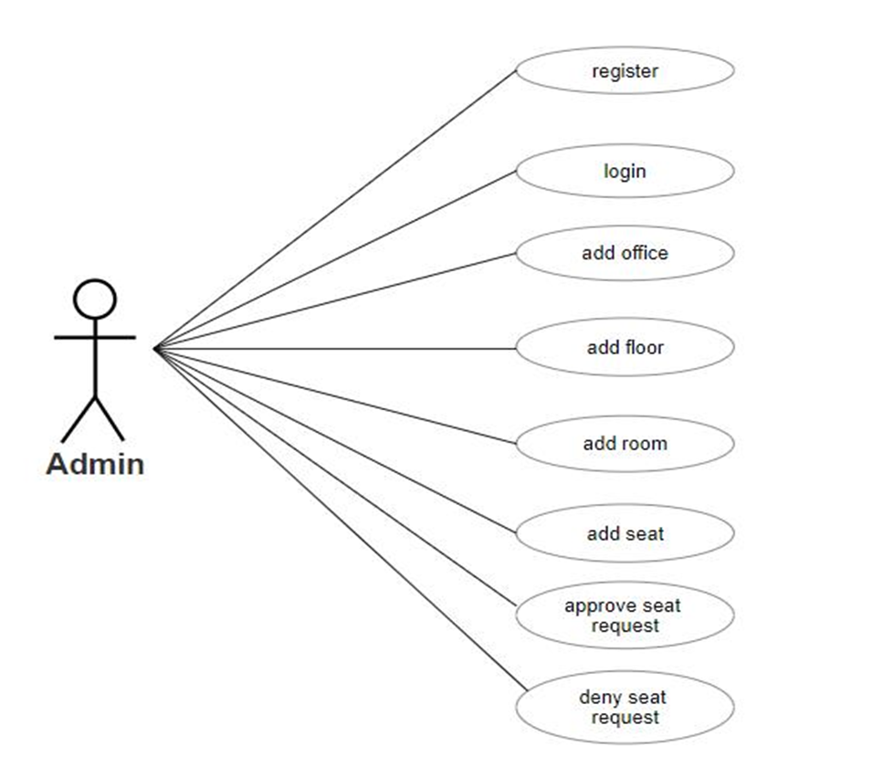

5.2 Class Diagram:

Class Diagram:

5.3 Sequence Diagram:

Sequence Diagram (for User Login):

5.4 E-R Diagram:

Entity-Relationship Diagram:

6.FUTURE ENHANCEMENT

Seat swap request:

•User should be able to send request for Swap of seats with the other user without Admin's involvement